ONLINE LEARNING MANAGEMENT SYSTEM FOR ULTIMATE UNIVERSITY

Name: **PETER PANG KHER YONG**

Coventry Student ID: **13446167**

Supervisor Name: **ASVHINI**

BCSCUN

School of Engineering and Technology, INTI International College Penang

26th June 2023

# TABLE OF CONTENT

Abstract 1

CHAPTER 1 INTRODUCTION

* 1. Project Introduction 2
  2. Problem Statement 3 - 4
  3. Research Questions 4
  4. Objectives 4
  5. Clients, Audience, Motivations 5
  6. Scope 6

CHAPTER 2 LITERATURE REVIEW

* 1. Definition 7
  2. Study on the existing system/existing technologies 8
     1. Canvas 8

Figure 2.2.1 Canvas 8

* + 1. Blackboard 9

Figure 2.2.2 Blackboard 9

* + 1. Moodle 10

Figure 2.2.3 Moodle 10

* 1. Comparison of the existing technologies/system 11
  2. How it was in deriving to the proposed work 12

CHAPTER 3 RESEARCH METHODOLOGY

* 1. Waterfall Model 13

Figure 3.1 Waterfall Model 13

* 1. Application of Research Methodology 13 - 14
  2. Use Case Diagram 15

Diagram 3.3 Use Case Diagram 15

* + 1. Use Cases 16
    2. Relationships 16

REFERENCES 17 - 18

# ABSTRACT

The goal of this project is to create and put into use a web-based platform that makes it easier to administer and deliver online courses. The goal of this project is to create an interface that is simple to use and incorporates key functionalities including communication, grading, and content management. The LMS will give lecturers the tools they need to efficiently assess learning outcomes and monitor student progress.

To identify their important characteristics and evaluate them against other systems, current LMS platforms like Blackboard, Canvas, and Moodle will be critically analyzed in this research. This comparative research will help us pinpoint the areas where the suggested LMS can provide special features and advancements.

An online learning management system platform with a full suite of capabilities for course management, content distribution, collaboration, and evaluation are one of the project's anticipated objectives. The platform will be made to be adaptable and user- friendly, enabling customization to fit the unique needs of educational institutions. By offering a strong and effective learning management system, the initiative seeks to improve online education.

# CHAPTER 1 INTRODUCTION

## Project Introduction

Online learning has become increasingly prevalent, offering flexible and accessible educational opportunities to a wide range of learners in nowadays. Strong and user- friendly platforms are essential to facilitating the delivery of online courses as the demand for effective online education rises. Due to this reason, online learning management systems (LMS) have been created. These systems are the foundation of online education platforms and allow teachers to design, organize, and deliver courses in a virtual setting.

The goal of this project is to plan and create an extensive online learning management system that satisfies the changing requirements of teachers and students. The system offers a variety of features and functionalities to assist efficient course management, material distribution, student involvement, and assessment to provide a seamless and interesting online learning experience.

This project is crucial because it responds to the rising demand for online learning and the requirement for effective infrastructure to facilitate the delivery of digital courses. It can democratize education by supplying a successful online learning environment, eradicating geographic restrictions, and providing educational possibilities to people who might not have access to conventional classroom settings.

## Problem Statement

Due to usability concerns, limited interactivity, and poor support for different learning styles, the current online learning management systems (LMS) employed by educational institutions have lower student engagement and less desirable learning results (Rao, 2020).

Online learning has become a crucial component of education since the development of technology. To give students a more comfortable and adaptable learning environment, there are many universities which implements online learning management systems (LMS). However, there are still difficulties in putting into place a successful online learning management system that satisfies the requirements of both instructors and students. One of the difficulties which universities have when deploying online learning management systems is the absence of user-friendly interfaces.

The number of students taking distant education courses at degree-granting postsecondary institutions increased by 30% between 2000 and 2016 (National Center for Education Statistics, 2019), according to a report. Additionally, a study by the Babson Survey Research Group revealed that 30% of American students enrolled in higher education attend at least one online course (Seaman et al., 2018). These numbers reflect the rising popularity of online education in higher education.

The significance of online learning management systems in higher education is highlighted in a journal article by Kaur and Sidhu (2017) titled "Online Learning Management Systems and Technologies: A Review." The paper presents an overview of several online learning management systems and technologies, as well as their benefits and drawbacks. According to the paper's findings, a good online learning management system should be simple to use, offer interactive and interesting learning opportunities, and give sufficient assistance for both students and teachers.

In conclusion, if universities want to give their students a more adaptable and convenient way to learn, they must implement online learning management systems. However, there are difficulties in putting into place a successful online learning management system that satisfies the requirements of both instructors and students. The need for online education is increasing, and research has shown how crucial it is for online learning management systems to include user-friendly interfaces, interactive learning opportunities, and support for student involvement. Therefore, additional study and the creation of online learning management systems are required to address these issues and raise the standard of online education.

## Research Question

## How can we enhance the current online learning management system to encourage active involvement, improve the user experience, and support various learning styles to increase student satisfaction and enhance learning outcomes?

## Does the utilization of the online LMS lead to improved student engagement and participation in online courses?

## What factors influence user satisfaction with the online LMS?

## Objectives

1. To develop a web based online learning management system to engage and promote students’ participation via chat features and discussion boards.
2. To generate analytical result based on progress and performance of students for each module.

## Clients, Audience, Motivation

The educational institutions like schools, colleges, universities, and training organizations are some of the clients for the online learning management system. These organizations use the system to distribute educational content and control the learning process.

Teachers, professors, and trainers make up most users of the online learning management system. They utilize the tool to develop and deliver course materials, lead online discussions, monitor student progress, and give feedback. The system's secondary audience is made up of students or learners who use it to interact with the course materials, finish assignments, take part in conversations, and monitor their progress in learning.

The motivations of implementing and using an online learning management system are to enhance accessibility to educational resources, foster collaboration and communication between teachers and students, and streamline administrative tasks related to course management (Ellis et al., 2019).

## Scope

The first scope is **course management**. For example, provide tools for creating, managing, and organizing courses. This may entail the capacity to design courses, specify course requirements, establish evaluation standards, control enrollments, and monitor student development.

The second scope is the **assessment and grading**, such as include tools for making and using tests, assignments, quizzes, and exams. Include tools for automated grading, giving feedback, and tracking grades. Supporting various question kinds, timed exams, and grading scales that can be adjusted is something to think about.

The third scope is the **user roles and permissions**. The various user roles, such as administrators, lecturers, and students, should be defined. Include the ability to create and manage courses, upload content, grade students, and take part in conversations in the permissions and access levels you specify for each position.

The fourth scope is **user support and help resources**. Within the LMS, make available user support in the form of documentation, guides, FAQs, and help resources. Include tools that let users find pertinent help resources, get assistance, and report technical problems or issues.

Lastly, the fifth scope is **communication and collaboration**, such as enable the lecturers and students to communicate and collaborate within the LMS. This could include tools that encourage interaction and enhance group learning, such discussion forums, real-time chat, messaging apps, and email notifications.

# CHAPTER 2 LITERATURE REVIEW

## Definition

An online learning management system (LMS) is a software programme or platform that facilitates the management, delivery, and tracking of educational courses and training programmes over the internet. It gives teachers the resources they need to design and arrange course materials, grade student work, encourage teamwork and communication, and keep track of students' development (Eaton, P., & Severance, C, 2019).

## Study on the existing system/existing technologies

## Canvas



*Figure 2.2.1 Canvas*

Figure 2.2.1 shows the symbol of Canvas. Canvas is a popular LMS known for its intuitive and user-friendly interface. It includes a wide range of capabilities, including tools for collaborative learning, content production and distribution, grading, communication, and course management. A cloud based LMS, Canvas is renowned for its intuitive user interface and wealth of functionality.

One unique feature of Canvas is its "Learning Mastery Gradebook," which enables instructors to track and assess student learning outcomes and competencies (Fies, C., & Marshall, J., 2019). This feature provides a clear overview of student progress and helps instructors identify areas where additional support or intervention may be needed. Canvas’s strong external tool integration allows for seamless integration with various external systems, expanding the range of resources and tools available to instructors and learners.

Adaptive learning and complicated question types may not be well supported by Canvas, despite the platform's capabilities in usability and cooperation (Gonzalez, M. C., & Toval, 2020). Even though Canvas offers a variety of evaluation tools, organizations looking for more advanced assessment capabilities may need to add more integrations or customize Canvas.

## Blackboard

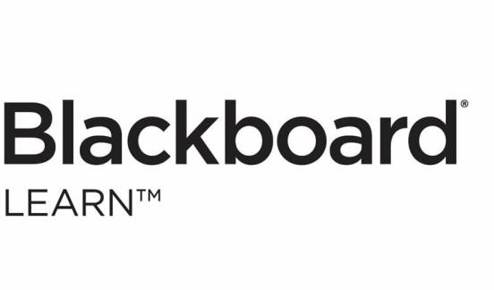

*Figure 2.2.2 Blackboard*

Figure 2.2.2 shows the symbol of Blackboard. In the field of education, Blackboard is a popular LMS. A variety of features are available, including collaboration tools, discussion forums, evaluation tools, and course management. Blackboard facilitates connection with outside systems and offers a user-friendly interface. It is well regarded for being reliable and scalable, making it appropriate for both little and big educational institutions (Blackboard.com, 2019). Throughout the world, educational institutions use Blackboard, a reputable LMS. It has tools for managing courses, delivering content, communicating, assessing students, and collecting analytics. Blackboard is renowned for its integrations and scalability (Tolentino, L. R., & Bagarinao, E. P., 2019).

One unique feature of Blackboard is its robust analytics and reporting capabilities, allowing instructors to track student progress and performance effectively. Additionally, Blackboard offers advanced tools for plagiarism detection and course accessibility compliance, providing a comprehensive solution for academic integrity and inclusivity (Blackboard, n.d.).

Collaborative document editing is a capability that systems like Google Classroom and Office 365 offer, but Blackboard does not natively allow it (Lai, Khaddage, & Knezek, 2020). While Blackboard does include tools for collaboration, the capacity for numerous users to edit and work together in real-time on documents is not as well integrated.

## Moodle



*Figure 2.2.3 Moodle*

Moodle is a well-liked open-source LMS that provides several tools for managing courses, conducting online tests, collaborating with others, and monitoring progress. Moodle offers a highly modular and adaptable architecture, allowing institutions to tailor the system to their specific needs (Moodle, 2019). Moodle's highly modular and adaptable architecture provides extensive customization options, enabling institutions to tailor the LMS to their specific pedagogical requirements. Moodle stands out due to its highly modular and adaptable architecture, which enables institutions to modify and expand the system to suit requirements. Due to its adaptability, Moodle enables institutions to customize it to meet their specific pedagogical needs and requirements (De Langen, 2019).

Moodle's wide selection of plugins and add-ons created by the community is one of its distinctive features. These plugins give organizations the ability to enhance Moodle's functionality and adapt it to their requirements (De Langen, F. H. T., 2019). Due to its versatility and flexibility, Moodle is a preferred alternative for organizations looking for customization possibilities.

In comparison to commercially supported systems like Blackboard and Canvas, Moodle may require more technical know-how and resources for initial setup, maintenance, and customization (De Langen, F. H. T., 2019). It may be difficult for institutions with little technological support or knowledge to take full advantage of Moodle's versatility.

* 1. **Summary of the existing technologies/system**

|  |  |  |
| --- | --- | --- |
| **Canvas** | **Blackboard** | **Moodle** |
| * Popular LMS known for its intuitive and user-friendly interface. * Offers a comprehensive set of capabilities, including collaborative learning tools, content production and distribution, grading, communication, and course management. * Widely accepted by educational institutions of all sizes. * Features a "Learning Mastery Gradebook" for tracking and assessing student outcomes and competencies. | * Popular LMS known for its reliability and scalability. * Offers a user-friendly interface and a wide range of features,   including collaboration tools, discussion forums, evaluation tools, and course management.   * Suitable for both small and large educational institutions. * Wide selection of plugins and add-ons created by the community. * Does not allow collaborative document editing | * Well-liked open-source LMS with a strong user community for support. * Provides tools for managing courses, conducting online tests, collaboration, and progress monitoring. * Highly modular and adaptable architecture, allowing institutions to customize the system to their specific needs. * Offers flexibility and adaptability for   institutions.   * Require more technical know-how and resources for initial setup, maintenance,   and customization |

## How it was in deriving to the proposed work

* **Identification of Key Features**

The essential features and functionalities that consumers usually need and appreciate by analyzing the existing LMS systems may be determined. This aids in identifying the crucial elements that ought to be present in the suggested LMS to satisfy the requirements of teachers, administrators, and students. It makes sure that the created system complies with consumer and business requirements.

## Evaluation of User Experience

Analyzing current systems enables the evaluation of various user experience (UX) elements. Effective UX design ideas, navigational patterns, and interface layouts can be learned by examining the advantages and disadvantages of various LMS systems. This aids in creating an LMS that is simple to use and enriches the user experience.

## Learning from Best Practices

Examining effective LMS platforms can provide ideas for good system architecture, database design, security precautions, and performance enhancement practices.

You can incorporate and modify their best practices to enhance the proposed LMS's design, performance, and scalability by learning how previous systems have addressed comparable problems.

## Addressing Limitations and Gaps

Researching current LMS technologies aids in spotting any restrictions or holes in the existing systems. You can concentrate on filling up the holes in the suggested LMS by being aware of what needs improvement or is lacking. In areas where previous systems might fall short, the new system will now offer improved functions, novel features, or improved performance.

# CHAPTER 3 RESEARCH METHODOLOGY

## Waterfall Model

The research methodology that I used for my project is the Waterfall Model.

The waterfall model is a well-liked method in software engineering and product development that follows a linear, sequential approach to the software development lifecycle (SDLC) (Lewis, 2019).

The waterfall model follows a logical succession of SDLC stages for a project, much like the way water pours over a cliff's edge. It establishes unique outcomes or objectives for every stage of development. After being achieved, certain endpoints or objectives cannot be changed (Lewis, 2019).

## Application of Research Methodology

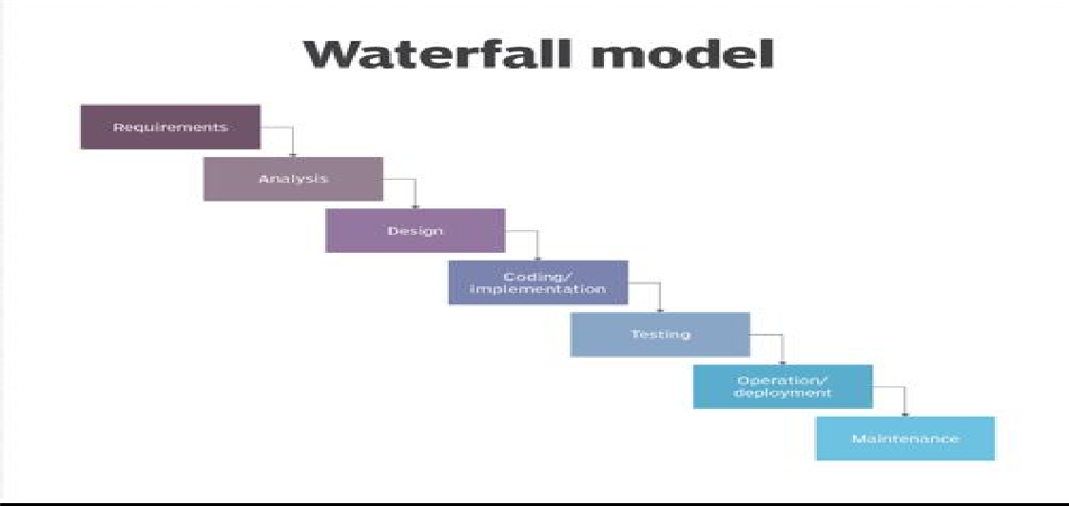

*Diagram 3.2 Waterfall Model*

## Gathering Requirements

During this stage, the online LMS's requirements are gathered and recorded. Understanding the demands of the various stakeholders, including educators, administrators, and students, is necessary for this. Features like course management, material delivery, evaluation tools, communication features, and reporting capacities may be included in the criteria.

## System Design

Based on the requirements acquired, a detailed design of the online LMS is created during the system design phase. This entails creating the user interfaces, database architecture, system architecture, and specifying the functionalities and interactions of various LMS modules.

## Implementation

Work on the online LMS is done during this stage. The development team creates the database, writes the code, and puts the specified functionalities into practice. Programming languages, frameworks, and other resources appropriate for creating web-based applications may be used during implementation.

## Testing

After the online LMS has been fully implemented, it is put through a thorough testing process. This includes various testing techniques like user acceptance testing (involving actual users to confirm the system's functionality and usability), system testing (testing the entire system as a whole), integration testing (testing the

interaction between various modules), and unit testing (testing individual components or modules).

## Deployment

The online LMS is launched into a live environment following successful testing and bug resolving. To do this, servers must be installed, the appropriate infrastructure must be configured, and the system must be made available to the intended users.

## Maintenance

The online LMS starts the maintenance phase after it has been implemented. As required, system improvements, bug fixes, and ongoing maintenance are carried out. To ensure the LMS runs smoothly, regular upgrades, security patches, and performance enhancements are made.

## Use Case Diagram

Use case diagrams are used to illustrate how a system is dynamic. However, given that the purposes of the other four diagrams, such as activity, sequence, cooperation, and State chart, which are all the same, this description is too general to adequately characterize the goal. We'll examine a special function that sets it apart from the other four diagrams (tutorialspoint.com, 2019).

Use case diagrams are used to compile a system's requirements, considering both internal and external factors. Most of these needs are for the design. Therefore, use cases are created and actors are identified when a system is analyzed to gather its functionality (tutorialspoint.com, 2019).

Below shows the use case diagram for my online LMS project:

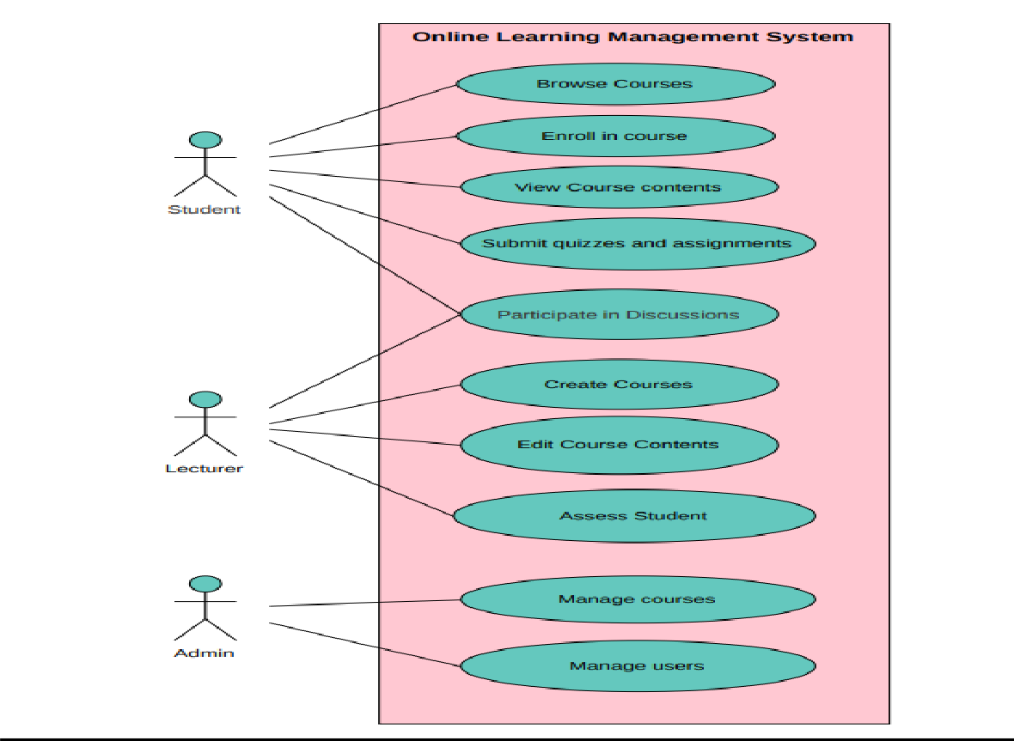

*Diagram 3.3 Use Case Diagram*

## Use Cases

**Manage Courses**: The administrator can create, update, and delete courses. **Manage Users**: The administrator can manage user accounts, including registration, login, and access permissions.

**Edit Course Content**: The educator can create and upload course materials such as lectures, documents, and multimedia.

**Assess Student**: The lecturer can evaluate student performance, grade assignments, and provide feedback.

**Participate in Discussions**: Both lecturers and students can engage in online discussions related to the course.

**Submit Quizzes and Assignments**: Students can submit their quizzes and assignments through the LMS.

**View Course Content:** Students can view course materials such as lectures, documents, and multimedia.

**Browse Courses**: Student can view modules, progress, grades, and completion status for courses.

**Enroll in Course**: Students may perform enrollment into courses during new semester.

## Relationships

The student has relationships with the "**Participate in Discussions**", "**Submit Quizzes and Assignments**", "**View Course Contents**", "**Enroll in Course**" and "**Browse Courses**" use cases.

The educator has relationships with the "**Create Courses**", "**Edit Course Content**", "**Assess Student**", and "**Participate in Discussions**" use cases.

The admin has a relationship with the "**Manage Courses**" and "**Manage Users**" use cases.

# REFERENCES

1. Lewis, S. (2019). What is waterfall model? - Definition from WhatIs.com. [online] SearchSoftwareQuality. Available at: <https://www.techtarget.com/searchsoftwarequality/definition/waterfall-model>.
2. tutorialspoint.com (2019). UML - Use Case Diagrams. [online] [www.tutorialspoint.com.](http://www.tutorialspoint.com/) Available at: <https://www.tutorialspoint.com/uml/uml_use_case_diagram.htm>.
3. Blackboard.com. (2019). North America | Blackboard.com. [online] Available at: <https://www.blackboard.com/>.
4. Instructure. (n.d.). Canvas Overview. [online] Available at: <https://www.instructure.com/canvas>.
5. Moodle (2019). Moodle - Open-source learning platform | Moodle.org. [online] Moodle.org. Available at: <https://moodle.org/>.
6. Al-Rahmi, W. M., Alias, N., Othman, M. S., & Saged, A. A. (2019). Integrating mobile learning features in learning management systems: A systematic review. Computers & Education, 138, 83-102.
7. Ellis, R. A., Han, F., & Pardo, A. (2019). Factors influencing higher education students’ satisfaction with learning in online environments: A systematic review. The Internet and Higher Education, 43, 100-115.
8. Rovai, A. P., Ponton, M. K., & Baker, J. D. (2020). Distance learning in higher education: A literature review and recommendations for the future. International Journal of Technology in Education and Science (IJTES), 4(4), 335-353.
9. De Langen, F. H. T. (2019). Moodle: An overview of the features and the future. International Journal of Educational Technology in Higher Education, 16(1), 15. doi:10.1186/s41239-019-0157-6
10. Fies, C., & Marshall, J. (2019). Comparison of Canvas, Blackboard, Brightspace, Moodle, and Schoology. In P. Resta & S. Smith (Eds.), Proceedings of Society for Information Technology & Teacher Education International Conference (pp. 2011- 2015). Association for the Advancement of Computing in Education (AACE).
11. Lai, C., Khaddage, F., & Knezek, G. (2020). Examining digital collaboration tools: The integration of Google Classroom and Blackboard Learn. Journal of Educational Technology Systems, 49(2), 242-262. doi:10.1177/0047239520903650
12. Gonzalez, M. C., & Toval, A. (2020). Evaluation of an LMS from a perspective of innovative teaching strategies. IEEE Access, 8, 45627-45637.

doi:10.1109/ACCESS.2020.2971596